import com.mongodb.client.*;
import com.mongodb.client.model.Filters;
import com.mongodb.client.model.Updates;
import org.bson.Document;
import java.util.Arrays;

public class MongoCRUDExample {
public static void main(String[] args) {
// Connect to MongoDB
MongoClient mongoClient = MongoClients.create("mongodb://localhost:27017");
// Access database
MongoDatabase database = mongoClient.getDatabase("vit");
// Access collection
MongoCollection<Document> collection =
database.getCollection("Students");
// ==========================
// CREATE (Insert)
// ==========================
Document student = new Document("id", 101).append("name", "John")
.append("department", "CSE")
.append("cgpa", 8.7);
collection.insertOne(student);
System.out.println("Document Inserted Successfully");
// ==========================
// READ (Find)
// ==========================
System.out.println("\nStudent Records:");
FindIterable<Document> students = collection.find();
for (Document doc : students) {
System.out.println(doc.toJson());
}
// ==========================
// UPDATE
// ==========================
collection.updateOne(
Filters.eq("id", 101),
Updates.set("cgpa", 9.2)
);
System.out.println("\nDocument Updated Successfully");
// ==========================
// READ Updated Record
// ==========================
Document updatedStudent = collection.find(Filters.eq("id", 101)).first();
System.out.println("\nUpdated Record:");
System.out.println(updatedStudent.toJson());
// ==========================
// DELETE
// ==========================
collection.deleteOne(Filters.eq("id", 101));
System.out.println("\nDocument Deleted Successfully");
// Close connection
mongoClient.close();
}
}
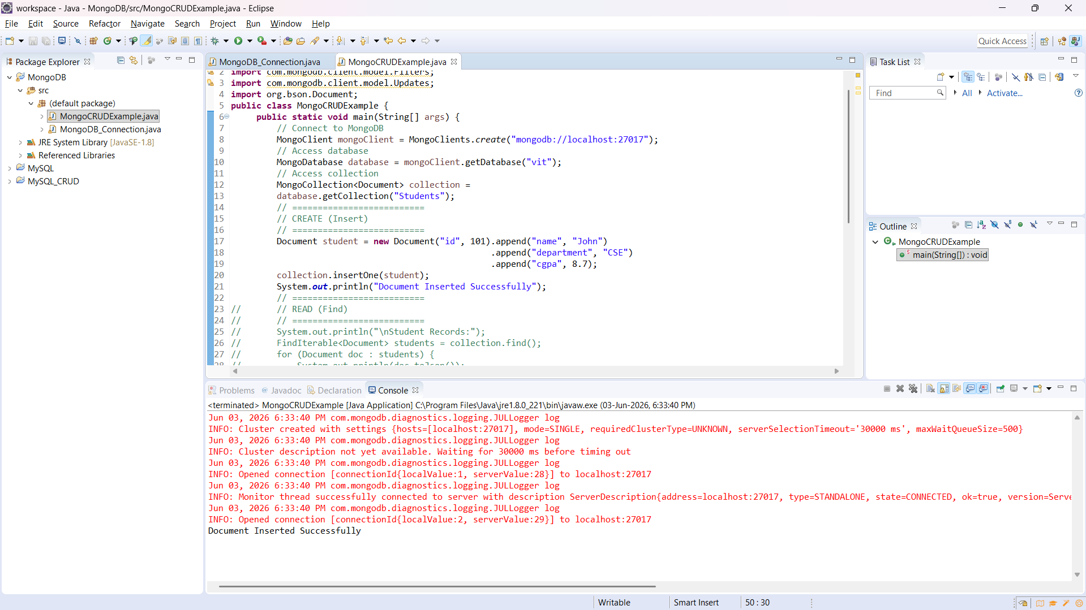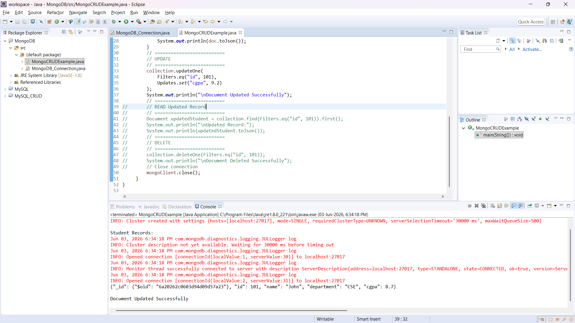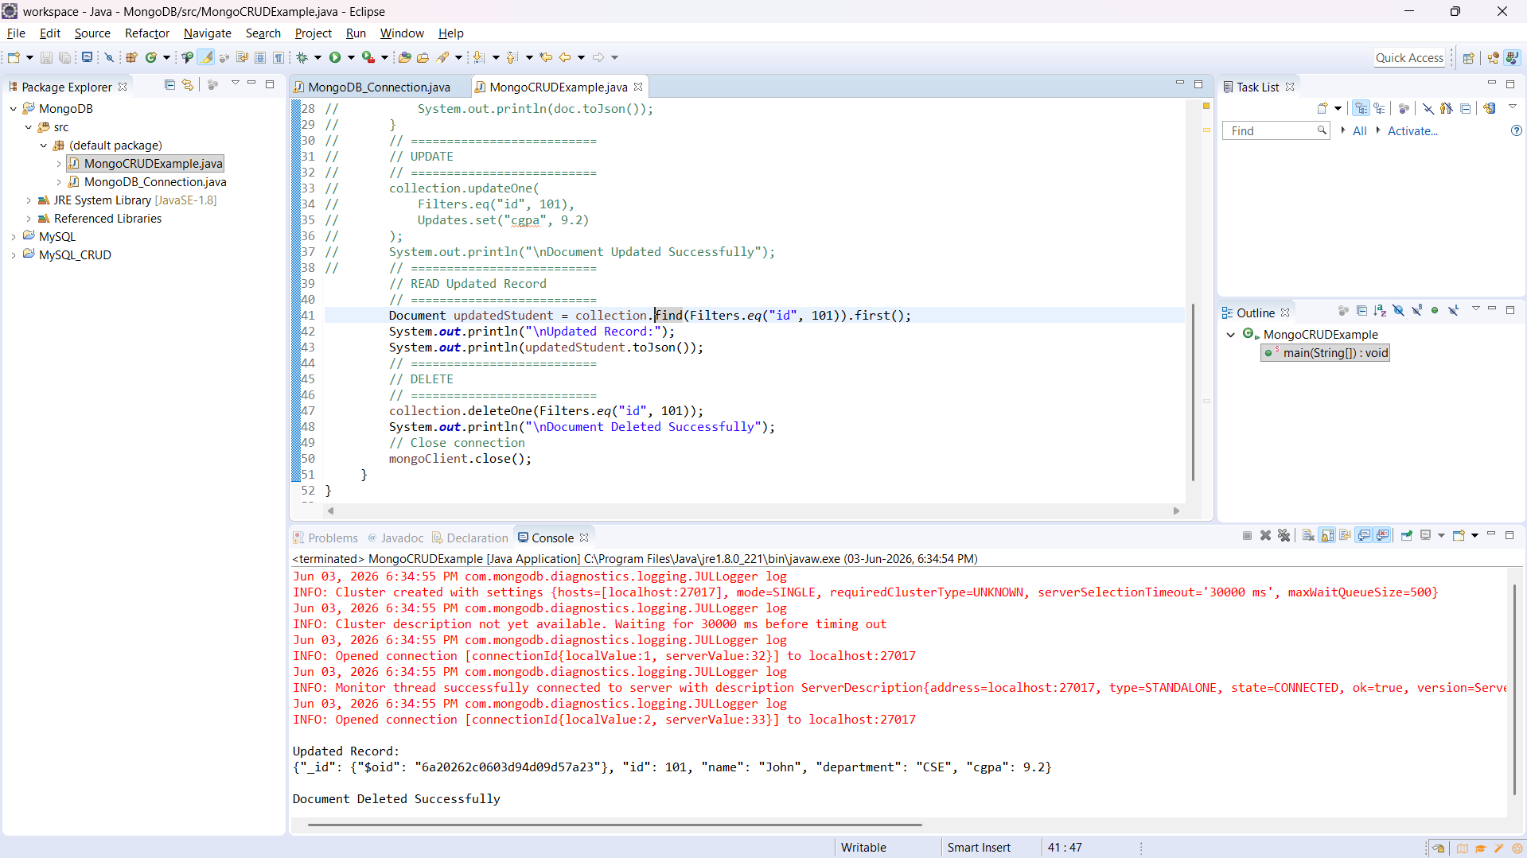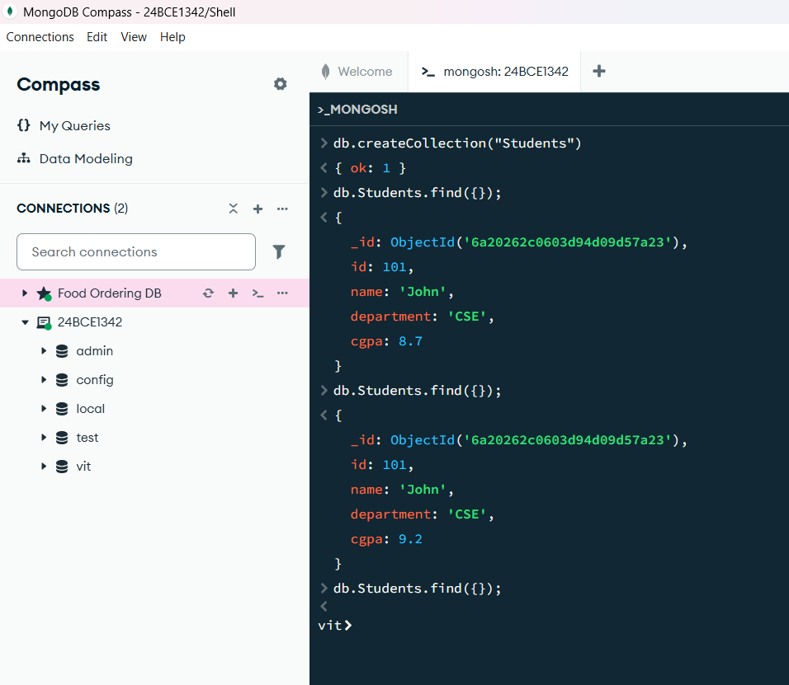
Insert Many: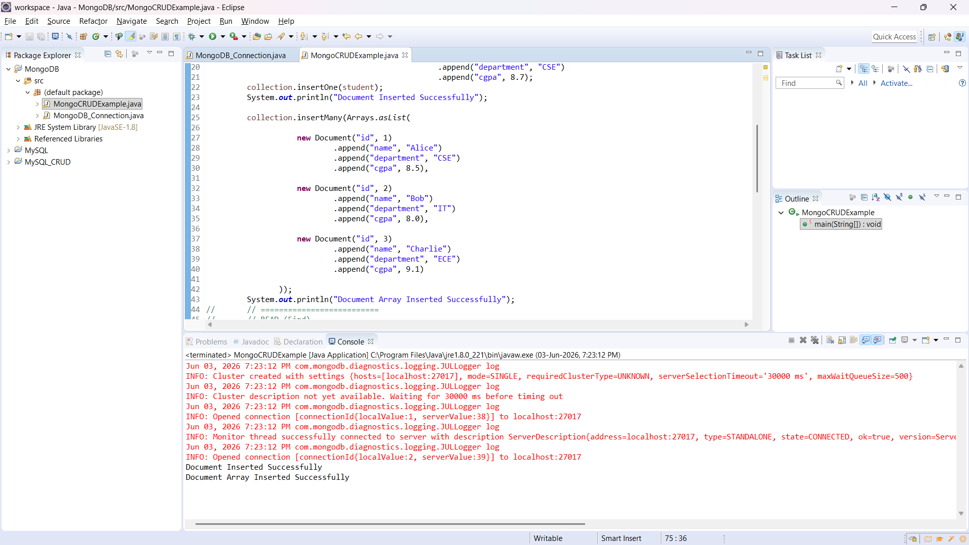
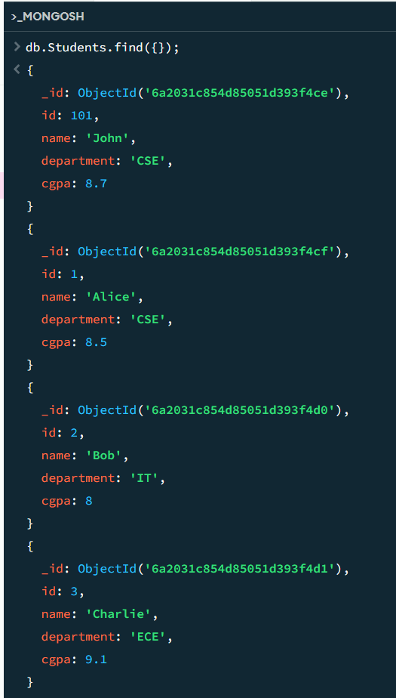

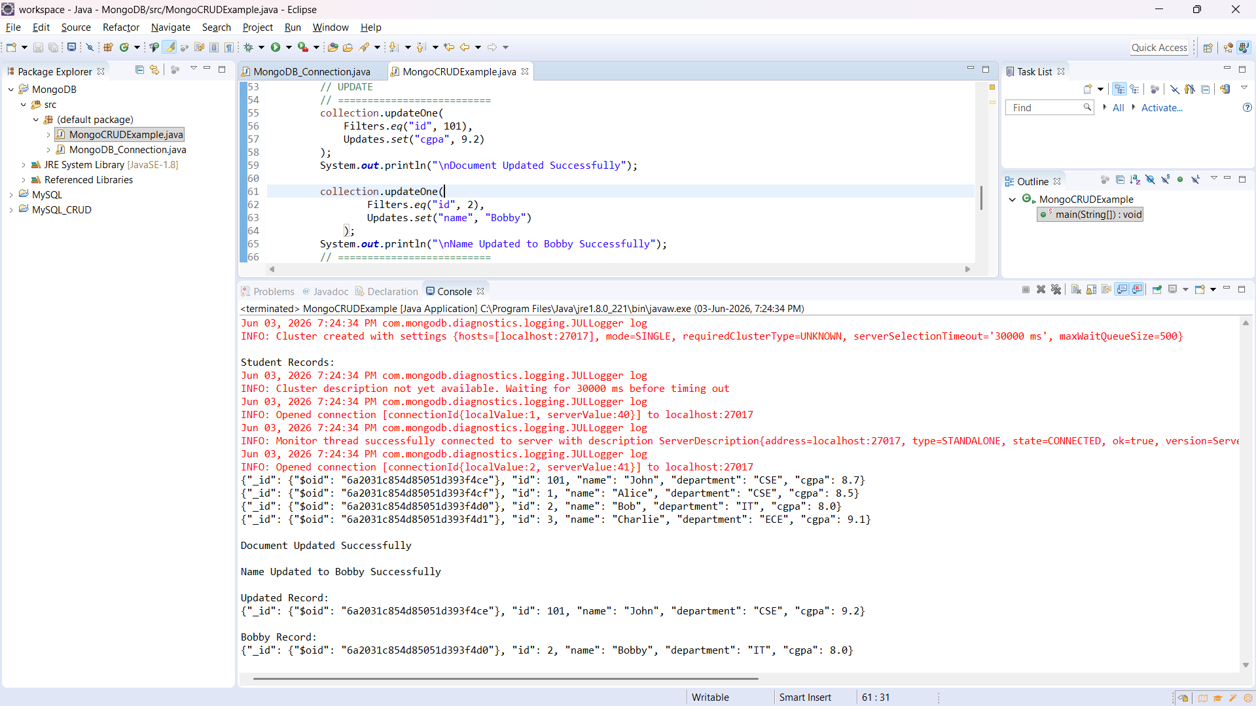
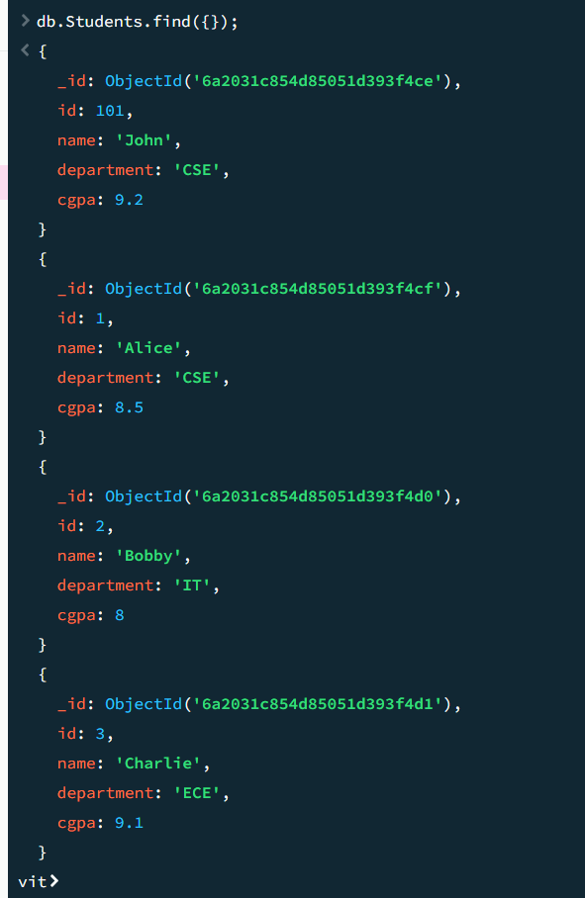

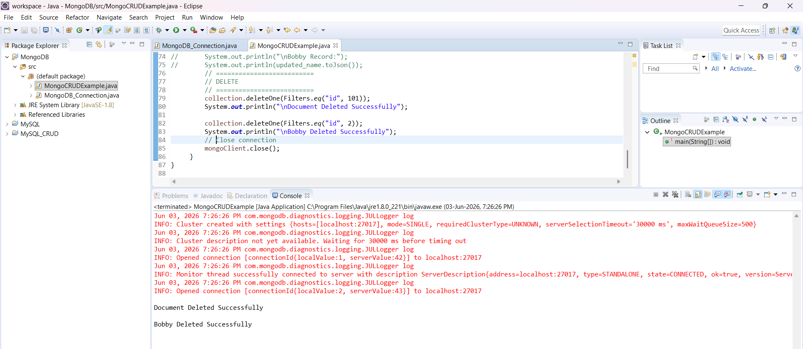
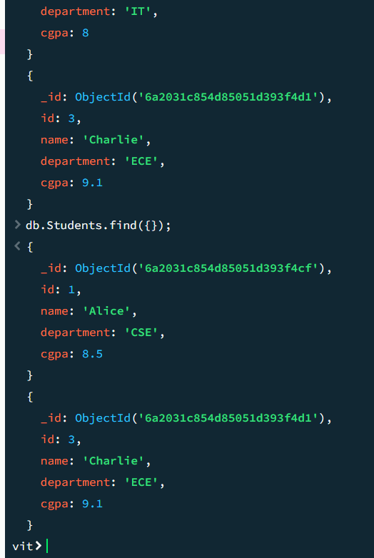
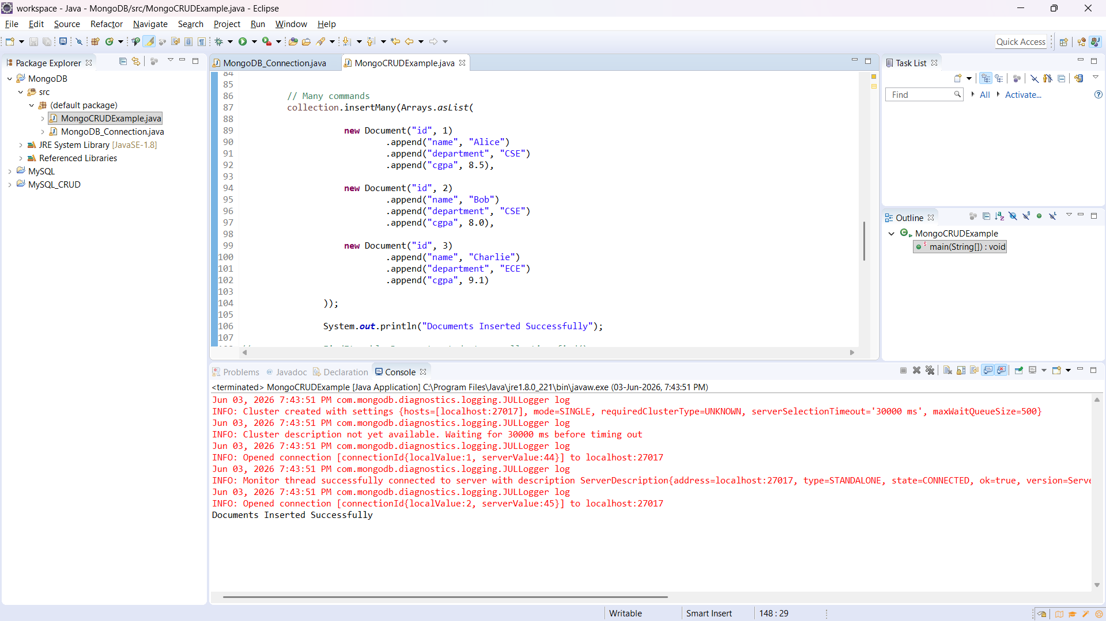
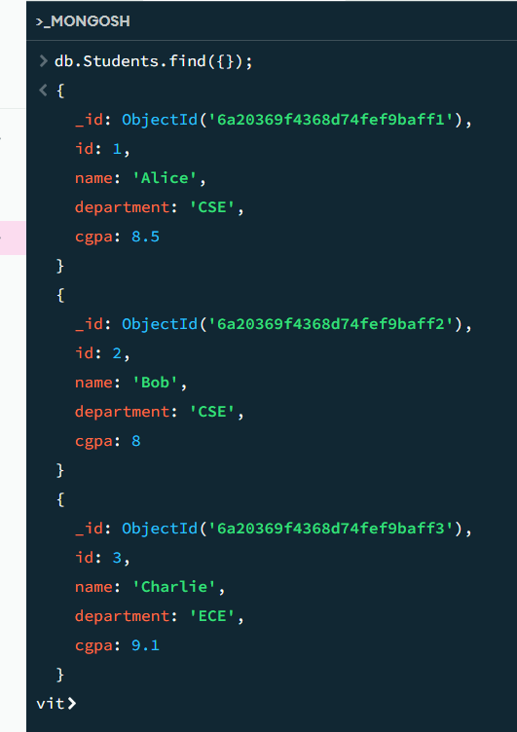
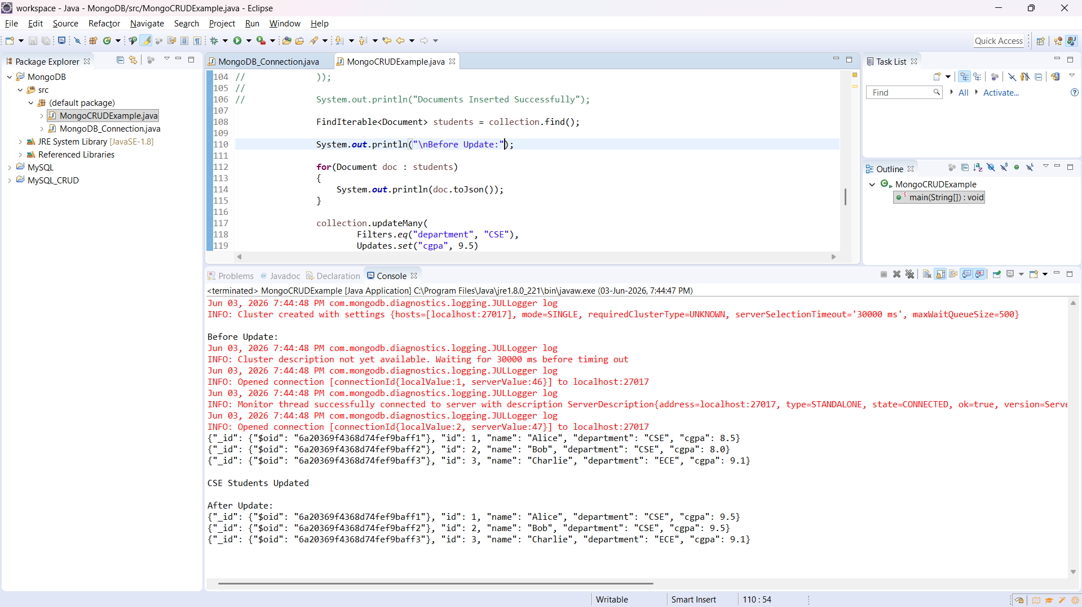
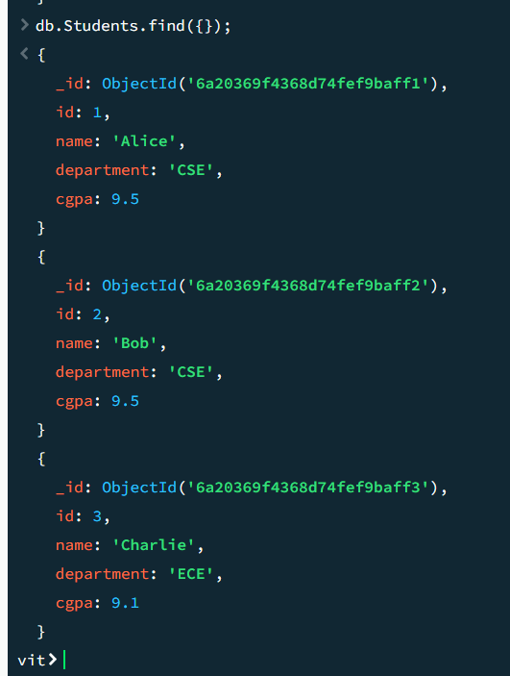
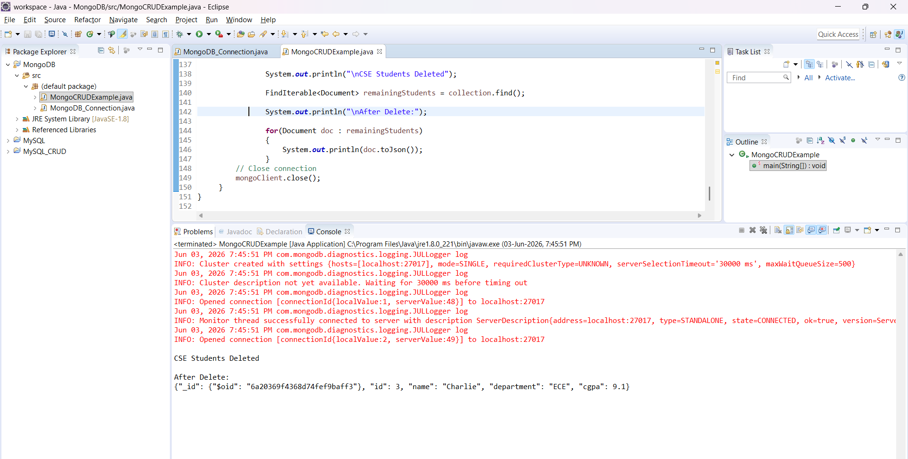
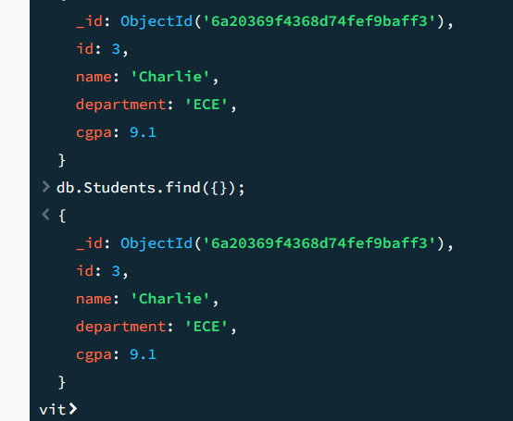

Final code with all the CRUD :
import com.mongodb.client.*;
import com.mongodb.client.model.Filters;
import com.mongodb.client.model.Updates;
import org.bson.Document;
import java.util.Arrays;

public class MongoCRUDExample {
public static void main(String[] args) {
// Connect to MongoDB
MongoClient mongoClient = MongoClients.create("mongodb://localhost:27017");
// Access database
MongoDatabase database = mongoClient.getDatabase("vit");
// Access collection
MongoCollection<Document> collection =
database.getCollection("Students");
// ==========================
// CREATE (Insert)
// ==========================
Document student = new Document("id", 101).append("name", "John")
.append("department", "CSE")
.append("cgpa", 8.7);
collection.insertOne(student);
System.out.println("Document Inserted Successfully");

collection.insertMany(Arrays.asList(

new Document("id", 1)
.append("name", "Alice")
.append("department", "CSE")
.append("cgpa", 8.5),

new Document("id", 2)
.append("name", "Bob")
.append("department", "IT")
.append("cgpa", 8.0),

new Document("id", 3)
.append("name", "Charlie")
.append("department", "ECE")
.append("cgpa", 9.1)

));
System.out.println("Document Array Inserted Successfully");
// ==========================
// READ (Find)
// ==========================
System.out.println("\nStudent Records:");
FindIterable<Document> students = collection.find();
for (Document doc : students) {
System.out.println(doc.toJson());
}
// ==========================
// UPDATE
// ==========================
collection.updateOne(
Filters.eq("id", 101),
Updates.set("cgpa", 9.2)
);
System.out.println("\nDocument Updated Successfully");

collection.updateOne(
Filters.eq("id", 2),
Updates.set("name", "Bobby")
);
System.out.println("\nName Updated to Bobby Successfully");
// ==========================
// READ Updated Record
// ==========================
Document updated_cgpa = collection.find(Filters.eq("id", 101)).first();
System.out.println("\nUpdated Record:");
System.out.println(updated_cgpa.toJson());

Document updated_name = collection.find(Filters.eq("id", 2)).first();
System.out.println("\nBobby Record:");
System.out.println(updated_name.toJson());
// ==========================
// DELETE
// ==========================
collection.deleteOne(Filters.eq("id", 101));
System.out.println("\nDocument Deleted Successfully");

collection.deleteOne(Filters.eq("id", 2));
System.out.println("\nBobby Deleted Successfully");

// Many commands
collection.insertMany(Arrays.asList(

new Document("id", 1)
.append("name", "Alice")
.append("department", "CSE")
.append("cgpa", 8.5),

new Document("id", 2)
.append("name", "Bob")
.append("department", "CSE")
.append("cgpa", 8.0),

new Document("id", 3)
.append("name", "Charlie")
.append("department", "ECE")
.append("cgpa", 9.1)

));

System.out.println("Documents Inserted Successfully");

FindIterable<Document> students = collection.find();

System.out.println("\nBefore Update:");

for(Document doc : students)
{
System.out.println(doc.toJson());
}

collection.updateMany(
Filters.eq("department", "CSE"),
Updates.set("cgpa", 9.5)
);

System.out.println("\nCSE Students Updated");

FindIterable<Document> updatedStudents = collection.find();

System.out.println("\nAfter Update:");

for(Document doc : updatedStudents)
{
System.out.println(doc.toJson());
}

collection.deleteMany(
Filters.eq("department", "CSE")
);

System.out.println("\nCSE Students Deleted");

FindIterable<Document> remainingStudents = collection.find();

System.out.println("\nAfter Delete:");

for(Document doc : remainingStudents)
{
System.out.println(doc.toJson());
}
// Close connection
mongoClient.close();
}
}

